

The Scriptures Inspired

Foundations for Faith Overview
We were never meant to do life alone—especially as followers of Jesus. Disciples grow best in community. Jesus himself modeled this concept by gathering a small group of followers to live and minister alongside Him every day. Even now when believers gather to seek God, relationships are forged, iron-sharpening discussions happen, and genuine accountability can develop.

During the next several sessions, you will journey together through foundational truths—or doctrines—of the Bible. Don’t let the word doctrine put you off. It simply refers to a teaching that comes from Scripture. Our doctrine impacts our decisions more than we might realize. For example, if we have a doctrinal belief that God heals, we are more likely to pray in faith, see Him deliver others from sickness, and experience our own healing. If we don’t believe in healing, we will not expect it or pray for it, and we may even speak out against it. The experiences we have as we follow Jesus largely depend on our doctrine.

The Book of Acts describes a group of Jews in Berea (17:10–15) who, like us, were seeking to better understand Scripture’s most foundational doctrines. After hearing Paul and Silas’s gospel message, they searched the Scriptures every day on their own to verify and fully understand the truth. The result? Many people believed the good news of Jesus and were changed for eternity. As you study Scripture and discuss doctrine together, may the Holy Spirit do the same for you.

SESSION OVERVIEW
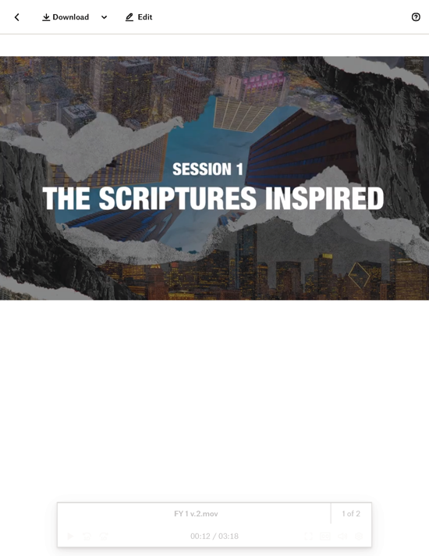

Foundation 1: WE BELIEVE the Bible is the verbally inspired and only infallible (incapable of being wrong) and authoritative (having authority over beliefs and conduct) written Word of God (2 Timothy 3:15–17; 2 Peter 1:21).1

The Bible contains sixty-six books written in three languages by over forty people. It covers a period of about fifteen hundred years and includes history, poetry, prophecy, stories, and letters—all for the purpose of reconnecting us to the loving God who created us.²

How can a book written thousands of years ago make a difference in the way we live now? Why can we trust that it’s God’s message to us? And what does it mean to say it’s inspired by God? These are the questions we’ll address in this session. When we understand that the Scriptures are the inspired Word of God, we’re more likely to live them out as we follow Jesus. Reading the Bible is different from reading any other book; it’s engaging with truth that we can build our life on.

You Will Need | Getting Ready
- Four large pieces of paper labeled A, B, C, and D  - Tape  - Foundation Slide  - Consider the Bible Slides 1–3  - Bibles for every student, preferably all the same translation  - Sheet of paper  - Scissors  - Paper bag  - Pen or marker | - Attach one of the large labeled pieces of paper to the wall in each corner of the room.  - Cut a sheet of paper into 25 equal slips, and mark one with an X.  - Place all the slips of paper in the paper bag and mix them up.

ENGAGE
Welcome
Take this time to welcome everyone, introduce new students, learn names, and thank everyone for coming. Your friendliness here can create a comfort level that encourages student participation later.

Opening Prayer
Prayer thoughts: Thank God for everyone present and for the journey you’ll take together over the next several weeks. Pray that everyone would be ready to hear from Him. Pray that everyone would grow in their relationship with Him as you talk about the Bible.

Introduction

Question
Who inspires you? What is it about that person that inspires you?

We’ve all been around people who inspired us to do something—like practice layups, learn a guitar riff, or write a poem. In a more influential way, the authors of the Bible were inspired by God to record the most important words in human history. God made sure that each writer fully captured His words, thoughts, and character so we could get to know Him.

Foundation: The Scriptures Inspired
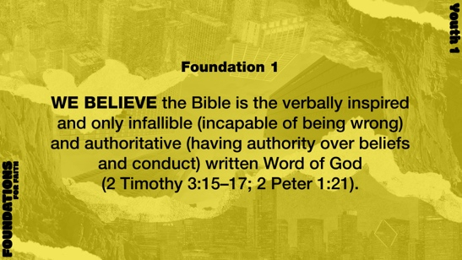

WE Believe the Bible is the verbally inspired and only infallible (incapable of being wrong) and authoritative (having authority over beliefs and conduct) written Word of God (2 Timothy 3:15–17; 2 Peter 1:21).

God guided the writers of the Bible to write every word in it, and now those words guide us through life. Do any of you have a Bible that uses red lettering for Jesus’ spoken words? Well, from this perspective, the entire Bible could be written in red letters, because it is full of God’s words.

GAME | Bible Trivia
You Will Need | Getting Ready
- Four large pieces of paper labeled A, B, C, and D  - Tape | - Attach one of the large labeled pieces of paper to the wall in each corner of the room.

Before we go deeper into where the Bible came from and what it’s all about, let’s see how much you already may know about what’s in it. I’m going to ask a few multiple-choice trivia questions, and you’ll answer by going to the corner of the room that corresponds with your answer choice.
- The answers to each question are shown in bold text below.

- How many books are in the Bible? (A: 30; B: 44; C: 52; D: 66)
- Which person did not write one of the Gospels? (A: Luke; B: Paul; C: Matthew; D: John)
- Who was Jesus’ mother? (A: Mary; B: Tabitha; C: Elizabeth; D: Martha)
- What sea did Moses part for the Israelites to escape Pharoah’s army? (A: Black Sea; B: Sea of Galilee; C: Dead Sea; D: Red Sea)
- Which name describes one of the two main parts of the Bible? (A: Major Hymns; B: Apostles; C: Rule Book; D: Old Testament)
- Which language is not one of the three the Bible was originally written in? (A: Aramaic; B: Greek; C: Japanese; D: Hebrew)

- Have students return to their seats.

Maybe you know a lot about the Bible or maybe you don’t know that much yet. Either way, there are a few big questions we all need to answer. First, what does it mean to say that the Bible is inspired by God? Second, how do we know that we can trust what the Bible says? And third, what difference does the Bible make in our everyday life? That’s what we’re about to find out.

Watch
Let’s watch this video to focus in on today’s foundational truth.
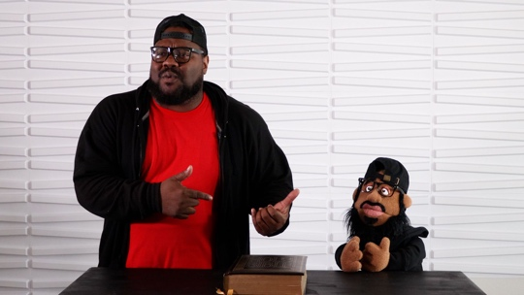
- Play the Foundations for Faith Youth Video.

CONSIDER WHAT THE BIBLE SAYS
You Will Need | Getting Ready
- Foundation Slide  - Consider the Bible Slides 1–3  - Bibles for every student, preferably all the same translation  - Sheet of paper  - Scissors  - Paper bag  - Pen or marker | - Cut a sheet of paper into 25 equal slips, and mark one with an X.  - Place all the slips of paper in the paper bag and mix them up.

Ensure each student has access to a Bible, preferably the same version.

What does it mean to say that the Bible is inspired by God?

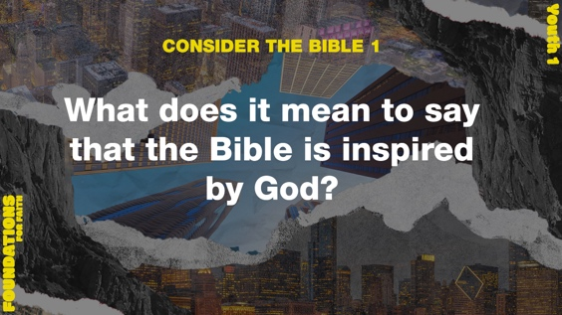
Let’s talk about the first big question: What does it mean to say that the Bible is inspired by God?
- Read 2 Timothy 3:16–17.

Question
What are the five ways that Paul said the Scriptures are useful for us?

The word Paul used for inspired literally means “God-breathed.” Like a musician breathes into an instrument to produce a melody, God breathed into the writers of the Bible to produce His Word. This kind of inspiration means God was the cause that brought about the effect. God’s Holy Spirit inspired every single word that the original authors recorded.

Question
When we realize the Bible is God’s inspired Word—not just words and thoughts from human authors—how should it change the way we read it?

Question
Do you have an example of how God’s Word has taught, corrected, or prepared you? Tell us about it, if you’re comfortable sharing.

How do we know that we can trust what the Bible says?

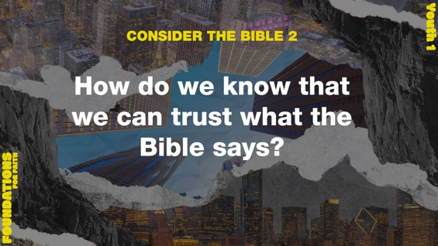
Let’s move on to the second big question: How do we know that we can trust what the Bible says? Well, there are lots of reasons to trust God’s Word, but one of the most amazing is the way the prophecies in it have been fulfilled.

A very simple definition of prophecy is God giving a person a specific message He wants them to share. Sometimes it reveals new info about the present. But sometimes it’s info about the future. Hundreds of years before Jesus was born, God inspired Old Testament prophets to record specific details about His life on earth as a human. And every single one of them happened! Let’s take a minute to think about how amazing that is.

Okay, I put twenty-five slips of paper in this bag, and one of them has an X on it. Is there anyone here who thinks they can find the paper with X on their first try?
- Choose a volunteer to pick one piece of paper out of the bag without looking.
- If the student happens to pick the piece of paper with the X, say:
Wow! You had a 1-in-25 chance and picked the right one. Awesome job!
- If the student picks a piece of paper without the X, say:
That’s okay. You only had a 1-in-25 chance. So, the odds were that you wouldn’t pick the one with the X on your first try.

What if we made the odds even higher? Well, one professor did just that. He and his team calculated that the chance of Jesus fulfilling just eight Old Testament prophecies was 1 in 10¹⁷ (10 to the 17th power, which is a 1 with 17 zeros or 100 quadrillion).

Think of it this way. If you could take 100 quadrillion silver dollars and lay them over the state of Texas, the entire state would be covered in silver dollars—two feet deep! Now imagine you marked just one of those silver dollars with an X and hid it somewhere in Texas. Then you told a blindfolded man to search the whole state and pick up that one silver dollar on his first try. That’s the same chance the prophets would’ve had to write eight prophecies that all came true during one man’s life.3 What makes this more amazing is that there aren’t just eight prophecies about Jesus in the Old Testament—there are hundreds!

Question
Does this change your point of view about the truth of the prophecies in the Bible? Why or why not?

Let’s take a closer look at a couple of these prophecies fulfilled in Scripture. The first one was written about Jesus approximately seven hundred years before He was born.

Read Isaiah 7:14.

Question
What specific details did Isaiah prophesy about the Baby and His mother?

Question
The prophecy states He should be called (not named) Immanuel. What does Immanuel mean?

Now let’s read the fulfillment of the prophecy in Luke 1:26–38.

Question
How did Luke’s account match up with Isaiah’s prophecy?

Remember, Jesus was born about seven hundred years after Isaiah's prophecy, but He still fit all the details! The next prophecy we’ll look at was also given hundreds of years before being fulfilled on the Day of Pentecost.

Read Acts 2:4–6, 14–18.

Question
Which Old Testament prophet did Peter quote when the Holy Spirit was poured out?

Question
In what ways was Joel’s prophecy being fulfilled?

Even though Joel’s prophecy was given nearly five hundred years before the Day of Pentecost, it happened exactly as the Scriptures said—and it continues to be fulfilled today!

Question
Why does it matter that Old Testament prophecies are fulfilled in the New Testament?

Question
When you see prophecies fulfilled in Scripture, does it help you trust the Bible more? Why or why not?

Read 2 Peter 1:16–21.

You may remember that Peter was one of Jesus’ closest disciples. He spent about three years with Jesus, listening to Him, watching Him, and asking questions. The “experience” Peter mentions in verse 19 was Jesus’ transfiguration (Matthew 17:1–6). On that day, Peter, James, and John saw Jesus’ glory and divinity for themselves. The Old Testament prophecies were being fulfilled in Jesus—right before their eyes. This gave Peter more confidence in the rest of the Old Testament prophecies.

Question
Where did Peter say Old Testament prophecies came from?

Question
When we know that the prophets didn’t write things down from their own thoughts, how does that give us confidence in trusting the Bible?

Question
What do you think it means that the prophets “were moved by the Holy Spirit”?

All the prophecies in the Bible were and will be fulfilled because they were put there in the first place by the inspiration of the Holy Spirit. But the Bible isn’t just prophecies, of course. We can also have confidence in it because a lot of it is eyewitness testimony.

Question
Imagine a 100 percent verifiable, documented miracle happened at church last Sunday. The problem is, you weren’t there when it happened. What kind of questions would you have about the miracle?

Question
In order to get the best, most trustworthy answers to these questions, who would you want to talk to first?

The most trustworthy information about an event always comes from the people who were there in person. The stories in the Bible are no different. With that in mind, listen to how Luke starts off his Gospel account.

Read Luke 1:1–4.

Question
According to verse 4, why does Luke put so much emphasis on his careful investigation of the facts?

The Bible is true and trustworthy, but that doesn’t mean it’s just like any other nonfiction book. God’s Word is “alive and powerful,” and it shows us what we really think and what we really want (Hebrews 4:12). Even though it has more than forty human authors, there’s one God who was guiding and inspiring the entire process. That’s why we call it “God’s Word.”

What difference does the Bible make in our everyday life?

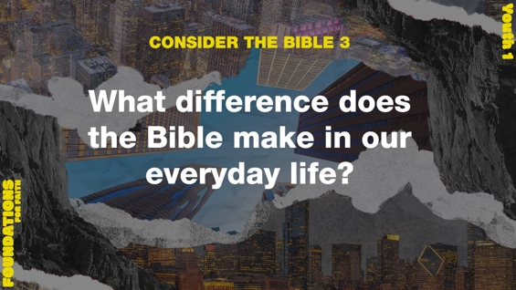
So when we know Scripture is inspired by God and it’s totally trustworthy, we have to ask our third big question: What difference does the Bible make in our everyday life?

Read Matthew 4:1–4.

Question
What did Jesus mean when He said we live by every word that comes from the mouth of God?

When Jesus was being tempted by the devil, He fought back with the truth of God’s Word. In verse 4, Jesus made a point of saying that words from God—which includes every single one in our Bible—are the key to our spiritual life. We may be able to physically survive without reading the Bible, but we can’t spiritually thrive. We’ll fall short of the meaningful life God has for us.

Read Psalm 119:105.

If you’ve ever gone camping or on a nighttime walk, you’ve probably used a flashlight to find your way in the dark. Without that light on your path, you’re way more likely to trip over something or totally lose your way.

Question
How is reading the Bible like shining a flashlight in the dark?

Read John 10:3–5, 27.

Imagine your phone lit up with a call from an “Unknown Caller.” Would you answer? What if the call was from your best friend or your parent? Most of the time, we’re way more likely to listen to someone we know and trust—and there’s nobody we can trust more than Jesus, our Good Shepherd.

Question
How is reading the Bible like listening to Jesus’ voice?

The Bible guides us as we listen to God’s words, believe them, and obey them through the Holy Spirit’s power. The Scriptures are God’s gift to us, helping us follow Him in this life and into eternity.

FOUNDATION FOR FAITH

WE BELIEVE the Bible is the verbally inspired and only infallible (incapable of being wrong) and authoritative (having authority over beliefs and conduct) written Word of God (2 Timothy 3:15–17; 2 Peter 1:21).

The Scriptures of the entire Bible are verbally inspired of God. It was not just the ideas that were inspired; even the choice of words was inspired as the original writers were moved by God to write what He wanted them to say. We therefore believe that (1) the Scriptures are God’s Word and way of revealing himself to humankind, (2) they are infallible (never wrong), and (3) they are the divinely authoritative guide for our faith, belief, and way of living (1 Thessalonians 2:13; 2 Timothy 3:15–17; 2 Peter 1:21).

Why Does This Matter?

If we don’t agree that all Scripture is a trustworthy guide given by God, we have no dependable standard on which to base our lives. Instead of having a guide that is fixed and reliable, everything becomes relative and uncertain. However, since God does not change, we can be certain that His truth won’t change. It can be trusted for all time, generations, and cultures.

REFLECT
Once we understand that God’s Word is inspired, we’re called to listen to it and do our best to live it out. That’s true whether we’re new at following Jesus or have been following Him for a long time. The content in our Bible is true and is there for our benefit. Reading and hearing it is a big part of how we learn who God is, what He expects from us, and how much He loves us. Ultimately, the Bible shows us how to live—both now and for eternity.

Listen to God
Let’s take time to think about whether our life shows that we trust the Bible. These questions are meant to start a conversation between you and God. Sharing your responses with the group is completely voluntary.
- Pause for a few moments of silent reflection after reading the questions. Then ask students if they want to share. Sharing your personal response may also be helpful to the students.

Question
How would you explain to someone that the Bible is God’s Word?

Question
Do you think you’ll spend more time reading the Bible after today’s discussion? Do you think it will be easier for you to trust what it says? Why or why not?

ACTIVATE
I challenge each of you to spend at least five minutes a day this week reading the Bible. If you’re already doing that, then just add a little more time each day. If you don’t know where to read, start in the Book of Mark. It’s a fast-paced story about the life and ministry of Jesus.

CONCLUSION

Have you ever played the game Telephone? Usually, by the time the message gets to the last person, it’s completely different. That’s why I’m so glad we have God’s Word written down. Not only are these God’s words to us, but they are stable and firm. They don’t change every time someone tries to remember what God said. In fact, billions of people have been living by these same words for more than two thousand years. We can have confidence that the Bible contains the truth God wants us to hear, understand, and live by.

Salvation Opportunity
Include this if you think there may be some in the group who do not have a personal relationship with Jesus.

Believing that the words of the Bible are true is a great start. Even if we don’t understand a lot about the Bible, we can know without a doubt that God loves us. He made sure that we had the info we need to have a good life—most importantly, how to make things right with Him and live forever (John 3:16).

Is anyone here that we can pray for who doesn’t have a relationship with Jesus or wants to renew their relationship with Him?

Take a moment to acknowledge those who respond, and thank them for their desire to make things right between themselves and God. Pray with them as you close in prayer or after the group time is over. Following group time, talk more about where they are in their walk with God and how you might be able to help.

Prayer
Father God, thank You for giving us the Bible so we can know who You are and how to follow You. Help those who have doubts about Your Word. For those who need faith to believe in You, show them who You really are. And give us all a hunger for the truth of Your Word. In Jesus’ name. Amen.

Dismissal
I look forward to seeing each of you next time. Don’t forget the challenge. Spend at least five minutes reading the Bible each day this week.

Endnotes

To read the full, official version of the Statement of Fundamental Truths, visit ag.org/beliefs/statement-of-fundamental-truths.
2 Portions of this session are adapted from Bible Engagement Project Youth Learn, Session 1.1 © 2021 by The General Council of the Assemblies of God, Springfield, Missouri 65802. Used by permission of the publisher.
3 “The Mathematical Probability that Jesus Is the Christ,” Empower International, accessed December 15, 2022, https://empower.global/the-mathematical-probability-that-jesus-is-the-christ.

